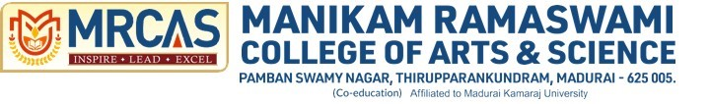

**SOCIAL INTERNSHIP**

BACHELOR OF SCIENCE

In

Dsa

By

Abzana V

C3S48851

Under the Supervision of

Mr. S. James

Duration: 18th June to 26th June, 2024

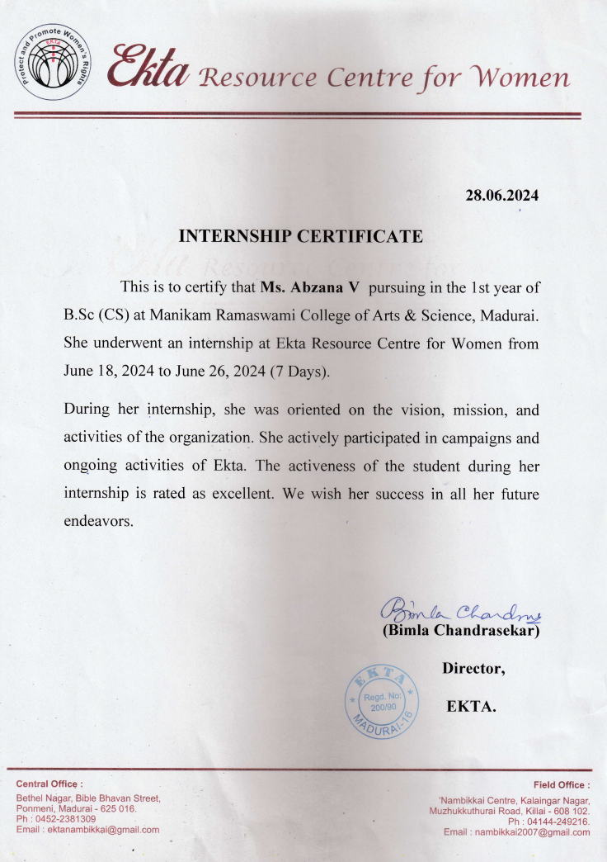

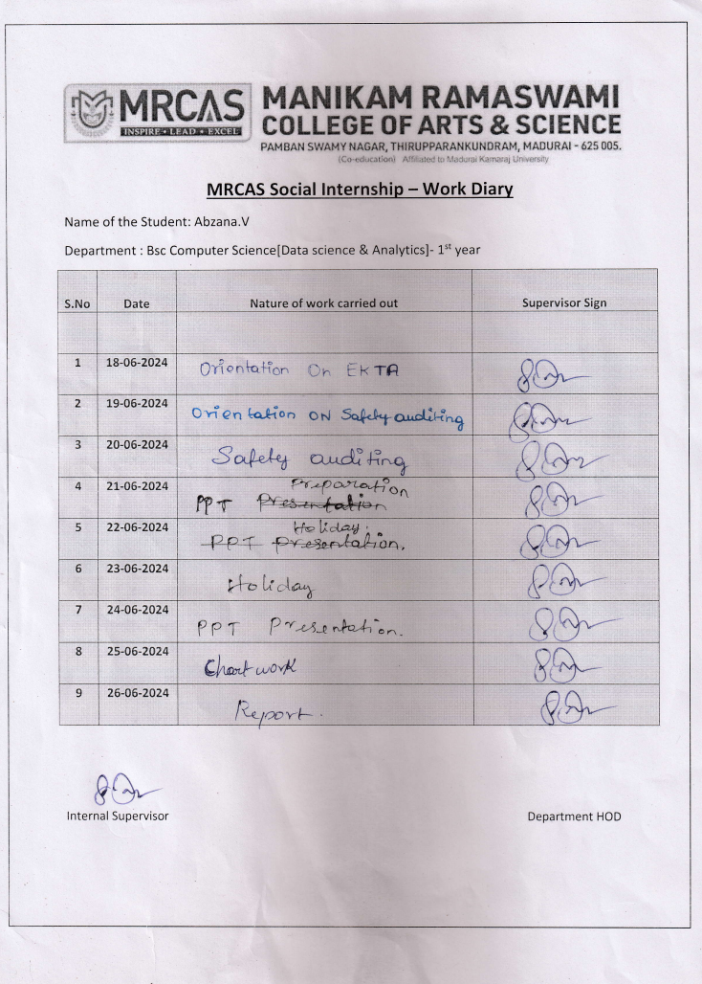

**ACKNOWLEDGEMENT**

I would like to express my sincere gratitude to Bimla Chandrasekar, director/secretary of the EKTA Resource Centre for Women, for accepting me to do my internship. I thank programme organizer James S of the EKTA Resource Centre for Women for being a mentor and for his unwavering support and help whenever needed in this internship program. I also thank members of the EKTA resource center for women for supporting in activities and field visits. I would like to extend our heartfelt gratitude to EKTA, Women Resource Center, for their invaluable support and contributions. Their dedication to empowering women and fostering gender equality has been instrumental in the success of our project. Special thanks to the entire team at EKTA for their unwavering commitment and passion. Their expertise and resources have significantly enhanced our efforts, providing us with the guidance and tools necessary to make a meaningful impact. Thank you, EKTA, Women Resource Center, for being an exemplary partner in our journey towards a more inclusive and equitable society. Your work continues to inspire and pave the way for positive change.

**THEME of Intern:**

EKTA, established in 1990 in Madurai, is a pioneering feminist resource center dedicated to achieving gender justice and empowering women through knowledge sharing, training, and alliance building. The organization focuses on preventing violence against women and children, promoting good governance, and sensitizing men and boys to the impacts of gender inequality. EKTA enhances the capacity of NGOs and CBOs through training on governance, human rights, and gender issues, and provides life skills education to adolescents. Key initiatives include the "Students for Change" program, the Nambikkai shelter for girls, and a Railway Childline Help Desk. EKTA also advocates for improved laws on domestic violence and sexual harassment, engages in various campaigns, and is part of several national and international networks. Through documentation, publications, and studies, EKTA disseminates critical information on gender issues, underscoring its pivotal role in advocating for gender justice and empowering women and girls in Tamil Nadu and beyond. This organisation trains more interns to learn work experience of an NGO and also sensitizes about gender-equal society and importance of children’s welfare. The intern wished to be a part of the organisation to render the service and to promote a gender inequality-free and justified society for women and children. Intern desired to work in several programmes like seminars, workshops, awareness programmes, life skill teaching, discussions and campaigns with EKTA. The intern was also interested in sharing the injustices which she observed during the past through EKTA may pave some small initiative to get rid of those injustices. This may done through content writing and discussions. The valid and effective points would be used in futuristic publications or any steps can be taken to sort out it.

**CONTENTS:**

1. Organization profile (brief history)
2. Introduction
3. Functional aspects of the organization (scope of various activities)
4. Day wise detailed activities :
   * + - * Orientation on EKTA
         * Orientation on safety auditing
         * Field visit
         * Discussion on safety auditing
         * Presentation of PPT
         * Discussion about the ppt
         * Updation of ppt presentation
5. Conclusion (learning outcomes)
6. Appendix

**INTERN DESCRIPTION**

Duration of internship: 7 Days (18.06.2024 - 26.06.2024)

Working hours: 5 hours/day (10.30 a.m. to 3.30 p.m.)

Mentor in the organisation: Mr.S.James (Programme Organiser)

**1.ORGANISATION PROFILE:**



EKTA was established in Madurai in 1990 as a resource centre for women that aims at gender justice by empowering women through knowledge sharing, training, and alliance building.

**1.1Mission:**

● Prevention of violence against Women and Children at all levels.

● Facilitation of good governance by promoting consultative, participatory and

inclusive practices.

● Sensitization of men and boys on the toxic impact of gender inequality in society

● Strengthen alliance, with organizing collaborations and networking at the state,

national and international level

**1.2Activities:**

*Capacity building trainings for NGOs and CBOs*

Capacity building is perceived as more than training, and an ongoing process through which individuals, groups, organizations and communities enhance their ability to identify and meet development challenges and move towards actualizing their rights. This process is pursued through planned trainings and exposure visits. Currently, the thematic areas have been brought under the following three broader headings with gender as the cross cutting concern.

**1.3Concerns in:**

Governance:

Strengthening women's participation and leadership

Human Rights:

Awareness on women's rights and legal literacy

Gender and Masculinities :

Awareness on the need for gender equality and the constructive role men can play in this process.

**1.4Life Skill Education for Adolescents and youth :**

Life skill Education for adolescents in select schools and communities are conducted to enhance their self esteem and to make them aware about their rights and entitlements. This programme was initially started for the Corporation school girls in the year 2000. Since then it has gone through a lot of modifications based on the suggestions of the adolescents and is continued in schools and communities.

**1.5Students for change**

The youth in colleges are given the orientation and taken through periodic thematic reflections on understanding gender, masculinities and the need for gender equality.This programme was started in 1994 in collaboration with National Service Scheme (NSS) of Madurai Kamaraj University. Later a survey was undertaken in some selected colleges among the students to assess their understanding about the situation of women in society and violence against women in particular. Following this a three day residential workshop was organised for the women students of the above colleges. At the end of this workshop a strong recommendation to have a continuous process with both females and students emerged. Therefore the students programme was given a gender and human rights focus and was implemented in colleges of Madurai. This was further strengthened by including the students into the White Ribbon Campaign. It was revised and renamed as 'students for Change' in 2005.

**1.6Counseling:**

Counseling is provided to women and their families. Based on the merit ofthe case, they are helped to access to get referrals to Police and Family Courts. For litigation process, we get the help of specialized agencies.

**1.7Nambikkai - Shelter for girls :**

Post Tsunami, EKTA started working in Chidambaram Taluk of Cuddalore district in Tamil Nadu, with a focus on strengthening education of girl children and livelihood rights of single women. Based on the expressed need of the communities, a shelter home for girls called Nambikkai was started in the year 2007. At present there are 35 girls are staying in the shelter to continue their education and also develop a plan for their future. The inmates are given health care,exposure to various development processes related to children, and are encouraged to participate in sports and other curricular activities, Since 2007 hundreds of girl children have availed this opportunity. After completing their school education, the children showing interest in higher education are supported in their college education.

**1.8Railway Child Helpdesk @ Madurai Junction :**

Childline

On 25 April, 2018, the Railway Childline 1098 Child Help Desk is in operation (24x7) in the Madurai Railway Station. The children have been rescued and handed over the Child Welfare Committee. We have been creating awareness regarding child protection in the railway station premises especially with the primary and secondary stakeholder on a regular basis. In addition awareness programs are organised by us for the public also.

**1.9Campaigns and Networking:**

EKTA envisages social change as a process of collective action. Therefore it works in collaboration with NGOs and other like-minded organizations. It also promotes networking among women to influence for appropriate implementation of existing policies and laws and demanding for relevant amendments and enactment of new laws. It is engaged in advocacy and policy dialogues to implement Domestic Violence Act, Prevention of Sexual harassment at the workplace and International conventions that GOI has endorsed and ratified such as CEDAW, PFA, SDG and CRC. The major campaigns are One Billion Rising Campaign and 16 Day Campaign to address Gender Based Violence.

**1.10Study Circles:**

*Knowledge Building and facilitating collective action of women*

The 'Study Circle' was initiated on the 14 January, 1992. The objective was to create a space for women from different professional backgrounds to come together to debate on women's issues and thereby evolve strategies or collective action. Now study circles are periodically held.

**1.11Documentation and publications:**

EKTA believes that information is power. It collects processes and disseminates among various stakeholders development information in Tamil and English through print and electronic media. EKTA also translates and publishes work that is politically relevant.

● Ten women Bicycle (Tamil translation)

● Patriarchy (Tamil translation)

● Understanding Gender (Tamil translation)

● What is a Girl? What is a Boy? (Tamil translation)

● Exploring Masculinity (Tamil translation)

● CEDAW (Tamil translation)

● Good Touch Bad Touch (Tamil)

● Namathu Udalum Seyalpattukalum

● Parakka Thudikirom

● Namathu Vazhvum Varalaru Agum

● Namathu Udal Namathe

● Sothanaikalai Savaalkalalki Saathikkum Pengal

● Handbook on Adolescent Girls (Tamil)

**1.12Research and Studies:**

● A study on socio economic status of women migrants in Madurai Slums.

● A preliminary study on the changing scenario in employment pattern for women

● A study to identify the forms of violence faced by women.

● A study on Grama Sabha in 6 districts of Southern Tamilnadu

● Study on Gender concerns in the context of Tsunami

● Old stories, New voices a collective reflection on the emerging challenges to Gender

equality

● A study on the structure and functioning of Family Courts in Tamilnadu.

● A study to understand the feminization of HIV/AIDS in 5 southern districts of

Tamilnadu.

● Single But not Alone

● Use of 498A in Tamil Nadu

● An Action Research Study on Experiences of Women Survivors of Violence in

Shelter Homes - Tamilnadu

**1.13EKTA members are in:**

● National Alliance of Women(NAWO)

● Girls Count, National level network

● Forum to Engage Men(FEM)

● SDG Watch - TN

● Lam Lynti Chittara Neralu (LLCN), National level network on Shelter for women

● South Asia feminist network for gender justice (SANGAT)

● Girls not Brides (Global Campaign)

● AMAN (National network on prevention of Domestic Violence)

**1.14Donors of EKTA**

● Azim Premji Foundation

● CESVI

● Christian World Service

● GLOBAL GREENGRANTS FUND

● Rebuild INDIA FUND

● Women’s Fund Asia

**1.15ORGANOGRAM OF EKTA**

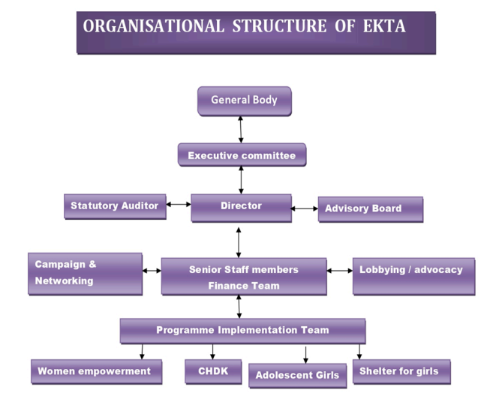

**2.INTRODUCTION:**

Founded in 1990 in Madurai, EKTA is a dedicated feminist organization working towards gender justice by empowering women through training, knowledge sharing, and building alliances. Its mission encompasses preventing violence against women and children, promoting inclusive governance, sensitizing men and boys to gender issues, and strengthening networks locally and globally. EKTA provides capacity-building for NGOs and CBOs, life skills education for adolescents, and engages college students in gender equality efforts. It offers counseling, manages the Nambikkai shelter for girls, and operates a Railway Childline Help Desk. Through advocacy, campaigns, study circles, and publications, EKTA tackles issues like domestic violence, sexual harassment, and women's rights. As part of multiple national and international networks, EKTA is a crucial advocate for gender justice and women's empowerment in Tamil Nadu and beyond.

**3.Functional aspects of the organization (scope of various activities):**

3.1 Capacity Building:

Target Groups: NGOs, Community-Based Organizations (CBOs), and community leaders.

Themes: Governance, human rights, gender, and masculinities.

Objective: Enhance the ability of organizations and individuals to address development challenges and advocate for women's rights.

3.2 Life Skills Education:

Target Group: Adolescents.

Focus Areas: Self-esteem, awareness of rights, and gender sensitivity.

Objective: Equip young individuals with the skills and knowledge to navigate life challenges and promote gender equality.

3.3 Students for Change:

Target Group: College students.

Partnership: National Service Scheme (NSS) of Madurai Kamaraj University.

Activities: Gender issue education and participation in the White Ribbon Campaign.

Objective: Foster gender equality awareness and activism among students.

3.4 Counseling Services:

Target Group: Women and their families.

Support Provided: Emotional support, legal assistance, and facilitation of access to police and family courts.

Objective: Provide comprehensive support to women facing violence or other challenges.

3.5 Nambikkai Shelter:

Target Group: Girls affected by the 2004 Tsunami.

Location: Chidambaram Taluk, Cuddalore district.

Services: Education, healthcare, and extracurricular activities.

Objective: Provide a safe and supportive environment for girls in need.

3.6 Railway Child Helpdesk:

Location: Madurai Junction.

Operations: 24/7 service since April 25, 2018.

Activities: Rescuing children and raising awareness about child protection.

Objective: Ensure the safety and protection of children at railway stations.

3.7 Campaigns and Networking:

Focus Areas: Domestic violence, sexual harassment, and implementation of international conventions (e.g., CEDAW).

Key Campaigns: One Billion Rising Campaign, 16-Day Campaign against gender-based violence.

Objective: Advocate for policy changes and raise awareness about gender justice issues.

3.8 Study Circles:

Target Group: Women from various professions.

Activities: Discussions and strategizing on women's issues.

Objective: Create a platform for collective action and knowledge sharing.

3.9 Documentation and Publications:

Languages: Tamil and English.

Focus Areas: Gender, patriarchy, children’s rights, and women's issues.

Objective: Disseminate crucial information and raise awareness through various media.

3.10 Research and Studies:

Focus Areas: Socio-economic status of women, employment patterns, violence, and gender concerns.

Objective: Conduct studies to inform policies and interventions addressing gender-related issues.

3.11 Networks and Memberships:

Associations: National and international networks like NAWO, Girls Count, FEM, SDG Watch - TN, and more.

Objective: Strengthen collaborations and advocate for gender justice on a broader scale.

**4.Day wise detailed activities :**

# Day: 1[18/06/24]



**4.1 Orientation on EKTA: Empowering Women and Girls in Madurai**

* **Overview and Establishment**:
  + Founded in 1990 in Madurai, EKTA is a feminist resource center dedicated to achieving gender justice through empowerment, knowledge sharing, training, and alliance building.
* **Mission Areas**:
  + **Prevention of Violence**: Addressing violence against women and children.
  + **Good Governance**: Promoting inclusive, participatory practices.
  + **Sensitizing Men and Boys**: Highlighting the impact of gender inequality.
  + **Strengthening Alliances**: Building local, national, and international networks.
* **Capacity Building**:
  + Conducts training for NGOs and CBOs under themes of governance, human rights, and gender and masculinities to enhance leadership, legal literacy, and gender equality.
* **Life Skill Education**:
  + Offers life skill education to adolescents to boost self-esteem and awareness of rights, continuously refining the program based on participant feedback since 2000.
* **Students for Change**:
  + Initiated in 1994 with NSS of Madurai Kamaraj University, rebranded in 2005, this program educates college students on gender issues and promotes gender equality.
* **Counseling Services**:
  + Provides counseling to women and families, facilitating access to police and family courts as needed.
* **Nambikkai Shelter**:
  + Post-Tsunami shelter in Chidambaram Taluk supporting 35 girls with education, healthcare, and extracurricular activities since 2007.
* **Railway Child Helpdesk**:
  + Operates a 24/7 help desk at Madurai Junction since April 25, 2018, rescuing children and raising awareness about child protection.
* **Campaigns and Networking**:
  + Engages in advocacy and policy dialogues, notable campaigns include One Billion Rising Campaign and 16-Day Campaign against gender-based violence.
* **Research, Documentation, and Memberships**:
  + Conducts studies on socio-economic and gender-related issues, disseminates information in Tamil and English, and is part of several national and international networks advocating for women's rights and gender justice.

These points capture the essence of EKTA’s multifaceted approach to empowering women and girls and its role in advocating for gender justice in Tamil Nadu and beyond.

**Day: 2[19/06/24]**

**4.2 Orientation on Safety Auditing and Women’s Safety in Madurai**

* **Systematic Safety Auditing:**
  + Conduct structured and independent safety audits to assess and enhance safety management systems at bus stands, bus stops, and railway junctions in Madurai.
* **Evaluation of Compliance and Risk Identification:**
  + Ensure compliance with safety regulations and identify potential hazards, focusing on women’s safety in high-traffic areas.
* **Infrastructure and Design Improvements:**
  + Address infrastructure deficits by installing adequate lighting, proper signage, and clear pathways to eliminate blind spots and secluded areas.
* **Enhanced Surveillance and Monitoring:**
  + Increase the number of surveillance cameras and ensure constant monitoring. Employ more security personnel, particularly female officers, to deter offenders and enhance security.
* **Safety Measures and Facilities:**
  + Implement emergency call boxes, well-lit waiting areas, and well-maintained restrooms. Ensure the presence of female security personnel to provide a sense of security and comfort.
* **Community Awareness and Training:**
  + Conduct training sessions for bus drivers, station staff, and commuters on handling emergency situations and recognizing signs of harassment to empower swift and effective action.
* **Creation of Safe Zones:**
  + Establish designated safe zones equipped with emergency call buttons and direct communication lines to security, ensuring immediate assistance is available in case of threats.
* **Regular Safety Audits and Feedback Mechanisms:**
  + Perform regular safety audits and set up feedback mechanisms for women to report concerns and suggestions, ensuring continuous improvement in safety measures.
* **Community Engagement and Collaboration:**
  + Partner with local organizations, women’s groups, and community leaders to foster a collaborative approach to enhancing safety through awareness campaigns and community policing.
* **Implementation of Proposed Strategies:**
* Execute proposed strategies to improve infrastructure, surveillance, and community engagement, aiming to create a safer and more inclusive environment for women in Madurai’s public transport hubs.

**Day: 3[20/06/24]**

**4.3 Field visit at Arapalayam Bustand in Madurai**

A safety audit is a systematic examination of a workplace to evaluate the effectiveness of its safety programs and procedures

This report examines the safety auditing process conducted at arapalayam

A thorough inspection of the area was conducted, covering all critical zones including bus terminals, waiting areas, restrooms and pedestrian pathways

**Restrooms:**

* Some restrooms are poorly maintained ,leading to slippery floors and unhygienic conditions that pose health risks
* There was no entrance door for the toilets and the toilets were surrounded by garbage like plastic cans, papers…,etc.
* There were two paid toilets and one was free to use but it was not in progress, no cleanliness
* The toilets for physically challenged was also not in progress and the walking ramp was broken, nowhere to be found
* In paid toilets , the 1st toilet was not much clean, but in 2nd toilet it was okay to use but the outside area was surrounded by garbage
* For women welfare I conclude that it was unsafe to use these toilets
* Toilets were well-lit, but lack security personnel nearby, making them potentially unsafe because there is no door but there is a screen its probably unsafe during late hours
* Public cooperation is essential in maintaining the cleanliness and functionality of public toilets. Please ensure you use these facilities responsibly and report any issues promptly.

**Bus terminals :**

* + The structure of bus terminals are require maintenance such as roof leaks and damaged flooring
  + Inadequate lighting and poorly maintained facilities can create unsafe environments, especially at night.
  + Lack of surveillance systems or non-functional CCTV cameras reduce deterrence against criminal activities
  + Lack of proper waiting areas, shelters, and clean facilities contribute to an unsafe atmosphere.

**Inadequate Security Measures :**

* Limited patrolling and police presence during late hours make these areas vulnerable.
* Limited or no presence of female security officers which can make reporting of incidents difficult for women.
* High congestion, especially during peak hours, can lead to higher instances of harassment and pick pocketing.
* Poor traffic control around the bus terminals, with insufficient signage and lack of pedestrian crossings, posing risks for both pedestrians and vehicles.

**Maintenance of feeding areas:**

* + Feeding areas are generally clean but lack proper maintenance and they are not in progress
  + We asked a old man near ,he said it’s always closed

As we are working under EKTA, resource center for woman we more concern about woman welfare

**Drinking water maintenance:**

* + Drinking water nowhere to be found and in some place .its poorly maintained. there was a water tanks near the washroom, and the water is unhygienic to drink it can cause several diseases
  + In some places the water tank was broken have been found
  + A new plastic recycling machine has been installed for public use. Public should utilize this facility to help reduce plastic waste and promote recycling efforts.

**Road maintenance:**

* + The road was not maintained properly, potholes and cracks can lead damage to vehicles, posing risks to motorists and pedestrians
  + Inadequate drainage systems lead to water logging during the monsoon season, exacerbating road damage and creating hazardous driving conditions.
  + We noticed mosquitoes were breeding in the drainage water and it cause malaria, dengue..etc.,
  + We observed that while the dustbins were properly maintained, but the area around the toilet was poorly kept. Immediate attention is needed to improve the cleanliness of the surrounding area.

**Public review:**

We gathered feedback from public sources including vendors and commuters at the bus stand to understand their perspectives

The bus stand lacks fire extinguishers, posing a significant safety concern for patrons and vendors alike. Immediate measures are needed to address this critical safety issue.

**Conclusion:**

The safety audit at arapalayam reveals that some measures are significant improvements are needed especially concerning women’s safety .Continous monitoring and periodic safety audit are essential to maintain and enhance these safety measures over time

**Day: 4[21/06/24]**

**4.4 Discussion on Safety Auditing at Arapalayam Bustand**

**[Field visit]**

* **Objective Definition**: We began by clearly defining the objective of the presentation, which is to assess and improve safety measures at Arapalayam Bus Stand.
* **Team Formation**: A dedicated team was formed, comprising members with expertise in safety audits, public transportation, and presentation skills.
* **Data Collection**: Conducted thorough data collection on current safety protocols, incident reports, and existing infrastructure at the bus stand.
* **Site Visits**: field visit were organized to observe and document the real-time safety conditions and potential hazards at the bus stand.
* **Stakeholder Interviews**: We interviewed key stakeholders, including bus stand management, staff, passengers, and local authorities, to gather diverse perspectives on safety issues.
* **Risk Assessment**: Performed a comprehensive risk assessment to identify critical safety concerns and prioritize them based on their potential impact and likelihood.
* **Best Practices Review**: Researched best practices in safety auditing and public transportation safety measures from other similar facilities and incorporated relevant examples.
* **Drafting Content**: Drafted the content for the PowerPoint presentation, ensuring it covered all key aspects of the safety audit, including findings, recommendations, and actionable steps.
* **Visual Aids Creation**: Developed visual aids such as charts, graphs, and images to effectively communicate the data and findings in the presentation.
* **Rehearsals and Feedback**: Conducted rehearsals to ensure smooth delivery of the presentation and gathered feedback from peers to make necessary adjustments for clarity and impact.

**Day : 5[24/06/24]**

**4.5 Power Point Presentation on Safety Auditing at Arapalayam Bustand**

### Introduction to Safety Auditing

* **Definition and Purpose of Safety Auditing**: Explained the concept of safety auditing and its importance in ensuring compliance with safety standards and identifying potential hazards.
* **Scope of Safety Auditing**: Discussed the areas and processes within Arapalayam Bus Stand that were subject to the safety audit, including passenger areas, maintenance zones, and administrative offices.

### Observations

* **General Safety Conditions**: Reported on the overall safety conditions observed at the bus stand, including cleanliness, orderliness, and availability of safety equipment.
* **Hazard Identification**: Identified specific hazards such as slippery floors, obstructed pathways, and poorly lit areas that could pose risks to passengers and staff.
* **Compliance with Safety Standards**: Assessed the bus stand’s adherence to established safety standards and regulations, noting areas of compliance and non-compliance.
* **Emergency Preparedness**: Evaluated the effectiveness of emergency preparedness measures, including the availability of first aid kits, fire extinguishers, and clear emergency exits.
* **Employee Safety Training**: Observed the level of safety training provided to employees, including their awareness and response to safety protocols and emergency procedures.

### Conclusion

* **Summary of Key Findings**: Summarized the main findings from the safety audit, highlighting both strengths and areas for improvement in the safety practices at Arapalayam Bus Stand.
* **Recommendations**: Provided recommendations for addressing identified hazards and improving overall safety, such as regular maintenance checks, enhanced employee training, and better signage for emergency exits.
* **Importance of Continuous Safety Auditing**: Emphasized the need for ongoing safety audits to ensure that safety standards are maintained and to proactively address any emerging risks

**Day : 6[25/06/24]**

**4.6 Discussion about PPT**

* **Purpose of the Visit**: Clarified the objectives of the safety auditing field visit at Arapalayam Bus Stand.
* **Key Findings**: Discussed the main findings and observations from the field visit.
* **Safety Concerns**: Addressed specific safety concerns identified during the audit.
* **Recommendations**: Proposed actionable recommendations to improve safety measures at the bus stand.
* **Stakeholder Engagement**: Discussed strategies for engaging stakeholders, including bus stand management and local authorities.
* **Follow-up Actions**: Agreed upon immediate and long-term actions to be taken based on the audit findings.
* **Implementation Plan**: Outlined a plan for implementing recommended safety improvements.
* **Training Needs**: Identified any training needs for staff and stakeholders related to safety protocols.
* **Documentation and Reporting**: Discussed requirements for documenting findings and reporting on progress.
* **Next Steps**: Agreed on the next steps, including timelines and responsibilities for each action item.

During our discussion on the PowerPoint presentation, we identified the need to add more points. Our organizer emphasized the importance of being informative, communicative, and educative (ICE). Subsequently, we collaborated on creating a chartwork focusing on the topics of National Conservation Day and Paper Bag Day.

**ICE Principles (Informative-Communicative-Educative)**:

* **Informative**: Ensure the content provides valuable information about the days.
* **Communicative**: Focus on effective communication strategies to engage the audience.
* **Educative**: Aim to educate and raise awareness about the importance of these observances

**Day : 7[26/06/24]**

**4.7 Report on Updated PPT: Safety Audit at Arapalayam Bus Stand**

* **Introduction**:
  + The updated PowerPoint presentation focuses on enhancing safety measures at Arapalayam Bus Stand, incorporating new findings and suggestions.
* **New Inclusion Points**:
  + **Emergency Response Plan**: Added a comprehensive emergency response plan outlining procedures for various emergencies.
  + **Improved Signage**: Recommendations for installing more visible and informative safety signs throughout the bus stand.
  + **Lighting Enhancements**: Proposals for improving lighting in dark areas to increase visibility and deter criminal activities.
  + **CCTV Coverage**: Suggestion to expand CCTV coverage to blind spots and ensure continuous monitoring.
  + **Safety Drills**: Regularly scheduled safety drills for staff and commuters to be well-prepared for emergencies.
  + **Waste Management**: Implementation of better waste management practices to maintain a clean and safe environment.
  + **First Aid Stations**: Establishment of easily accessible first aid stations equipped with necessary supplies.
  + **Staff Training**: Mandatory safety training programs for all staff members.
  + **Feedback System**: Introduction of a feedback mechanism for commuters to report safety concerns and suggestions.
  + **Periodic Audits**: Regular safety audits to monitor and improve safety measures.
* **ICE Technique Integration**:
  + **Information**: Detailed slides providing comprehensive information on current safety measures, statistics, and areas needing improvement.
  + **Communication**: Strategies for effective communication of safety protocols to commuters and staff, including announcements and digital displays.
  + **Education**: Initiatives for educating commuters and staff about safety practices through workshops, pamphlets, and on-site demonstrations.
* **Visual Enhancements**:
  + The presentation includes updated graphics, charts, and images to better illustrate the safety measures and improvements.
* **Stakeholder Involvement**:
  + Emphasis on involving various stakeholders, including local authorities, bus operators, and the public, in implementing and maintaining safety measures.
* **Technology Integration**:
  + Suggestions for leveraging technology, such as mobile apps and QR codes, for real-time safety updates and emergency contacts.
* **Case Studies**:
  + Inclusion of case studies from other bus stands with successful safety practices to provide practical examples and inspiration.
* **Cost Analysis**:
  + Detailed cost analysis of proposed safety measures to ensure feasibility and budget alignment.
* **Implementation Timeline**:
  + A clear timeline for implementing the recommended safety measures, including short-term and long-term goals.
* **Conclusion and Call to Action**:
  + Concluding remarks summarizing the importance of the safety audit and a call to action for immediate implementation of the suggested improvements.

**5.CONCLUSION:**

My internship at EKTA Resource Center for Women provided a comprehensive understanding of gender justice initiatives and the importance of safety audits in public spaces. Over seven days, I participated in various activities that highlighted EKTA's multifaceted approach to empowering women and girls. The safety audit at Arapalayam Bus Stand was a key focus, revealing significant areas for improvement, particularly concerning women's safety. The preparation and presentation of the PowerPoint on safety auditing underscored the need for continuous monitoring and stakeholder engagement to maintain and enhance safety measures. Overall, this internship reinforced the critical role of community involvement and regular audits in promoting a safer and more inclusive environment for women.

**6.Appendix:**

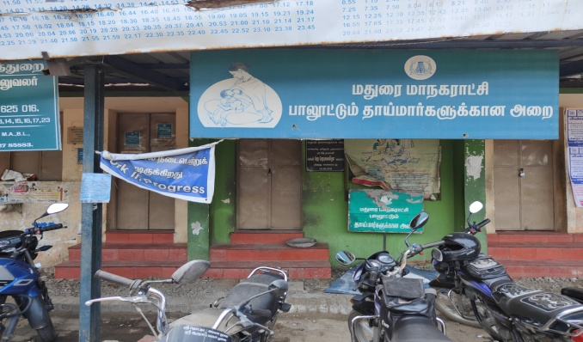

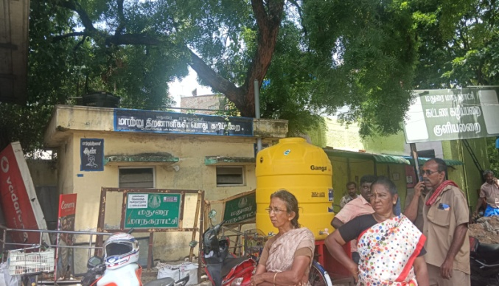

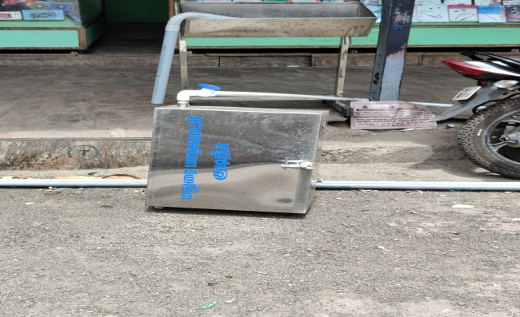

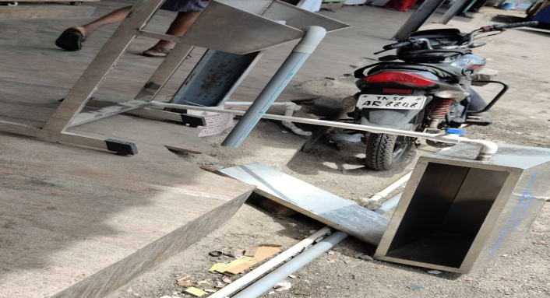

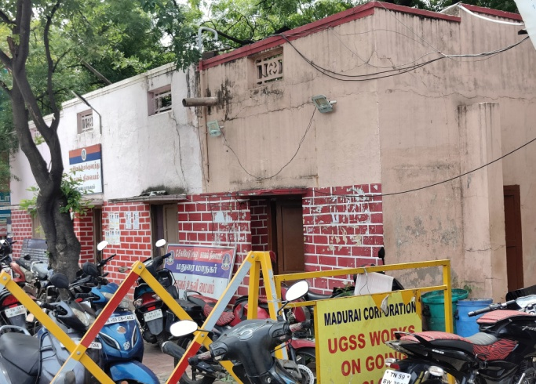

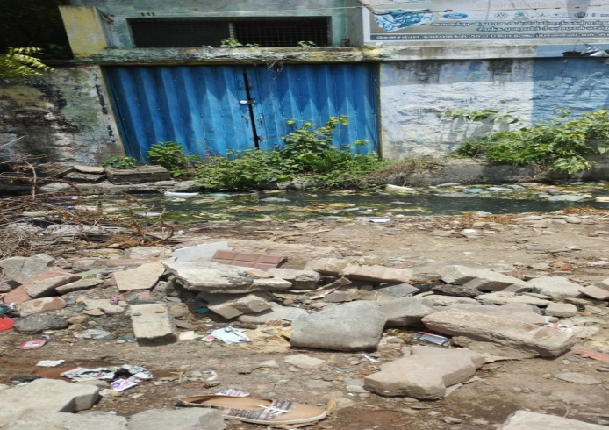

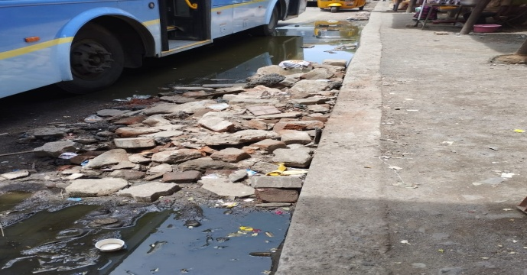

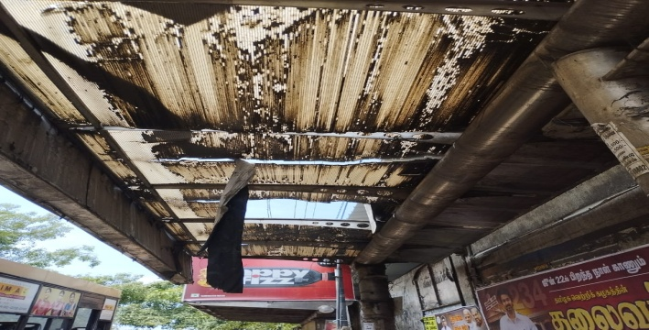

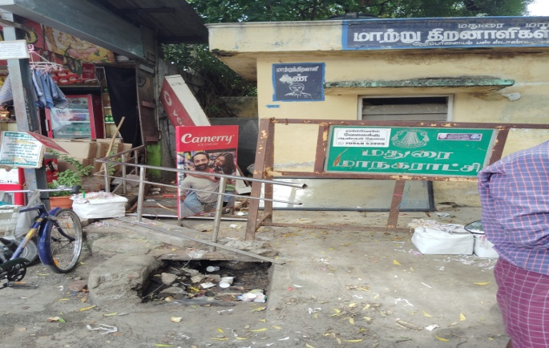

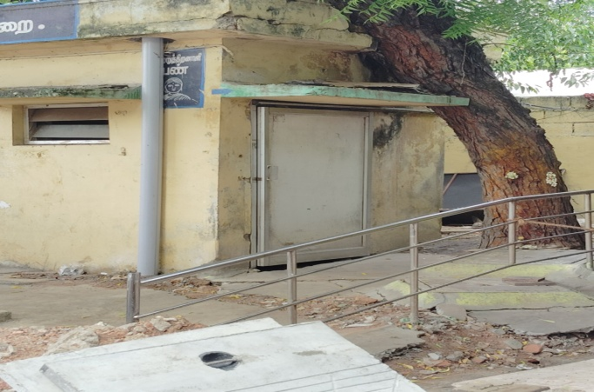

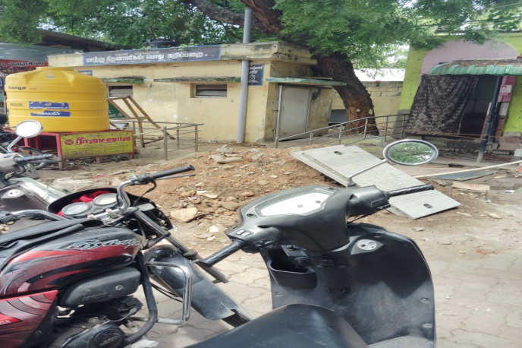

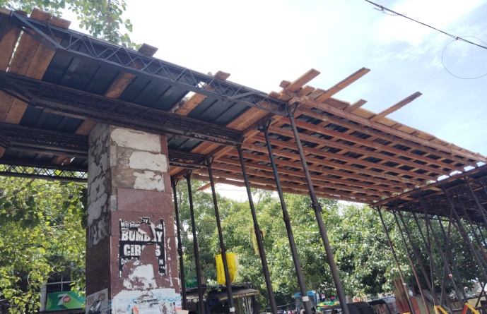

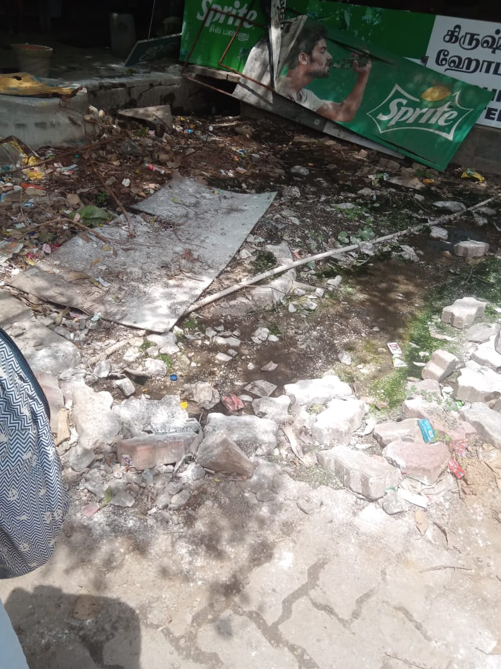

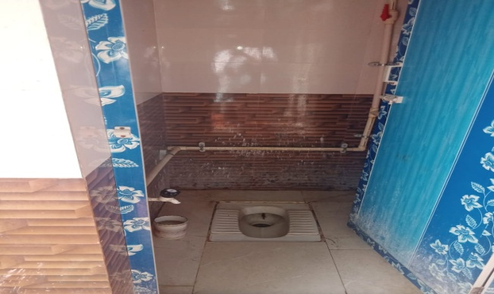

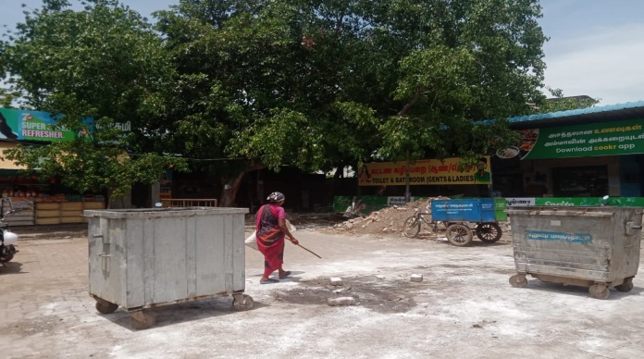

**6.1CHART WORKS:**